Server tuning
Description
Learn about different tuning methods
1.Pagespeed
2.Gzip compression
3.tuned daemon
Step 1:Installed PageSpeed Module and verified it
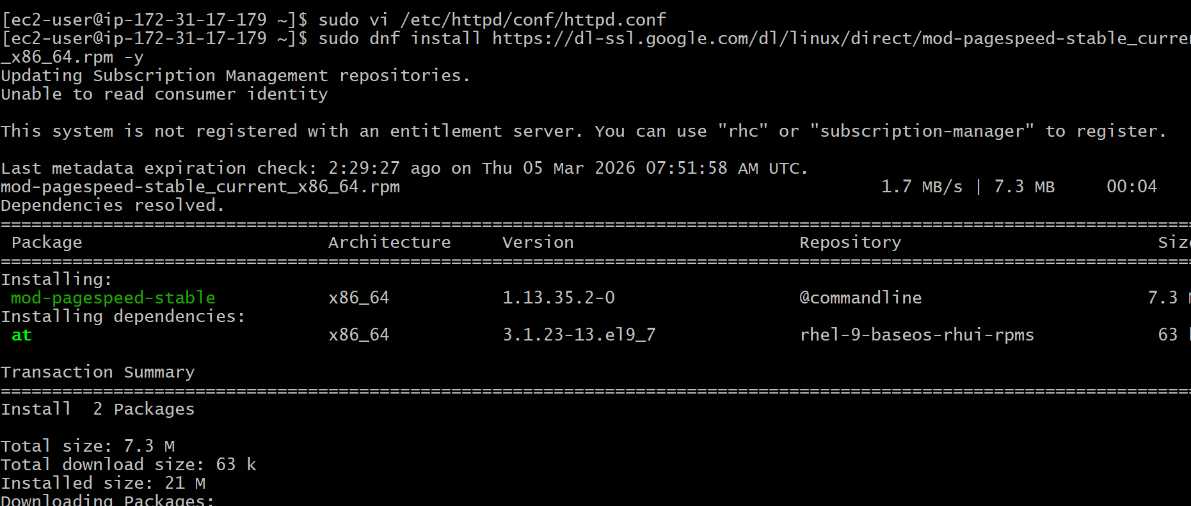

Step 2: Configured Gzip Compression and verified it

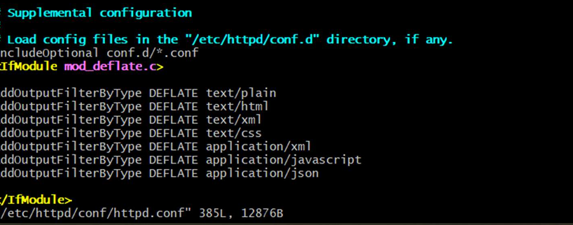
Step 3: Configured Tuned Daemon
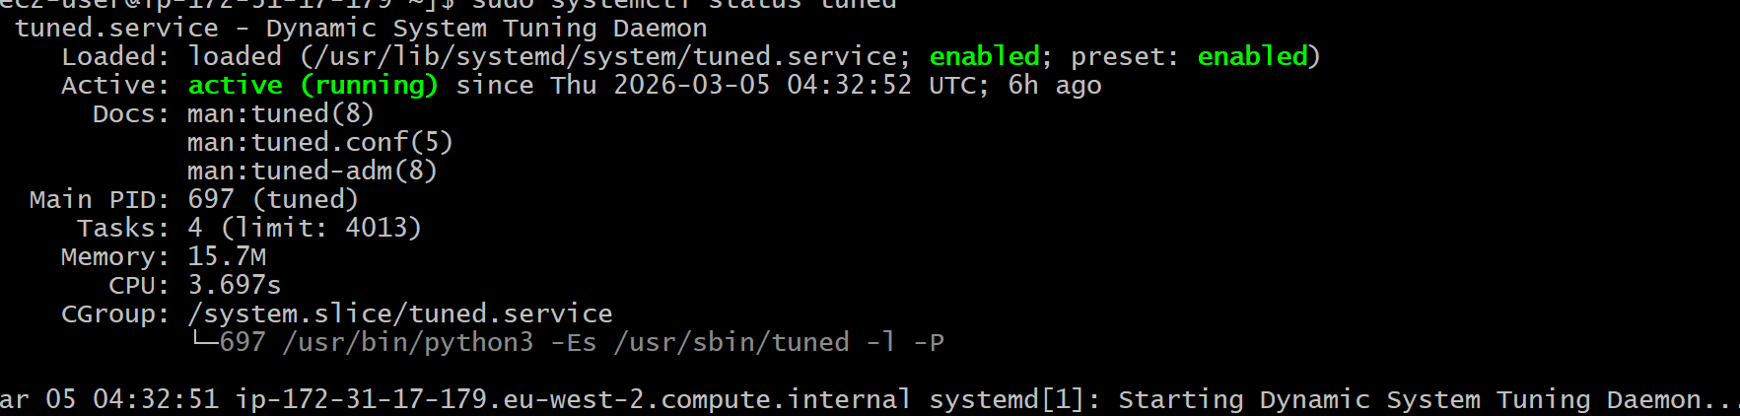
Set the performance profile
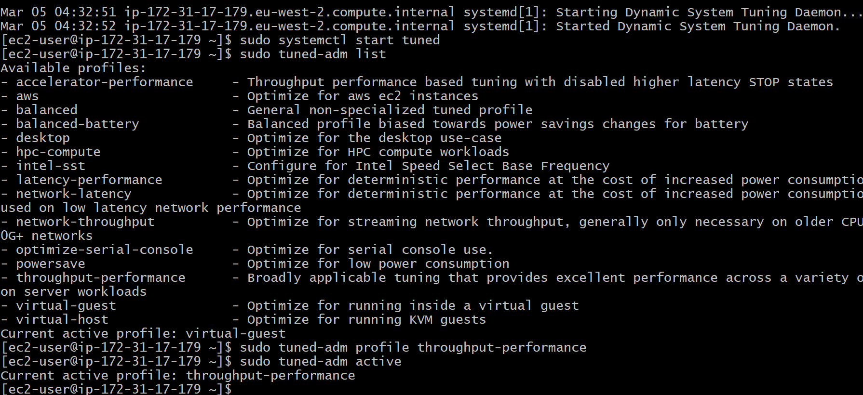

Step 4: Verified using browser
